ISD Safety Manual for the Universal Robots
CB2, CB3, and E-series controlled robots

Prepared by:
Jeremy Marvel

National Institute of Standards and Technology
100 Bureau Drive, Mail Stop 8230
Gaithersburg, MD 20899-8230

Version History:
2014-08-05 Original version
2016-02-01 Updated for inclusion of the UR5 with the CB3 controller
2016-11-08 Updated with new safety controller information
2024-12-09 Updated format to more closely match other SOPs for the Human-Robot Interaction Lab
Updated for inclusion of the e-series controller
Updated for general UR safety rather than based on specific models
Removed dual-arm configuration of UR10s
Added information regarding non-collaborative use

Table of Contents

1 Overview 4
2 Before You Begin: Safety 6
2.1 Industrial Robots 6
2.1.1 Non-Collaborative Applications 6
2.1.2 Collaborative Applications 6
2.2 Eye Safety 7
2.3 Hand/Skin Safety 7
2.4 Common Hazards 7
2.5 Required PPE 8
3 Robot Safety Controls 9
3.1 Integrated Robot Safeguards 9
3.1.1 Emergency Stop 9
3.1.2 Mechanical Hard Stops 9
3.1.3 Soft Axis Limit Switches 9
3.1.4 Collision Detection 10
3.1.5 Safety Input/Output Signals 10
3.1.6 Electronic Safety Circuit 11
3.1.7 Safety Rated Stopping Functions 11
3.2 External Safeguards 11
3.2.1 Emergency Stops 12
3.2.2 Light Tower 12
3.2.3 Laser Area Scanners 13
3.2.4 Pressure-sensitive Mats 13
3.2.5 Enabling Devices 13
4 Powering and Initializing the Robot 14
4.1 Turning on the Robot 14
4.2 Initializing the Robot 15
4.3 Moving the Robot 16
4.3.1 Commanding Motions Using the Move Screen 16
4.3.2 Jogging Using the Freedrive Button 17
5 Safety Verification Procedures 19
5.1 Verify Robot Activation 19
5.2 Verify Local E-Stop 19
5.3 Verify External E-Stop Buttons 19
5.4 Verify Teach Pendant Functionality 20
6 Working Inside the Robot’s Work Volume 21
7 Programming Using the Teach Pendant 22
7.1 Programming Outside the Robot Work Volume 22
7.2 Programming Inside the Robot Work Volume 22
8 Maintenance 23
9 Emergency Response Plan 24
9.1 Event: Equipment Fire 24
9.2 Event: Forceful Impact with Human 24
9.3 Event: Crushing/Pinching 24
9.4 Event: Contact with Forbidden Zones 25
9.5 Event: Robot Brake Failure 25
9.6 Event: Unexpected Robot Motion 25
9.7 Event: Unplanned Release of Energy 26
9.7.1 Electrical 26
9.7.2 Pneumatic 26
9.8 Event: Contact with Hot Parts of the Robot/Controller 26
9.9 Building Related Hazards 27
9.9.1 Event: Fire 27
9.9.2 Event: Hazardous Weather 27
9.9.3 Event: Power Outage 27

Overview

This safety manual outlines the standard operational procedures (SOP) and safety system features of the Intelligent System Division’s (ISD) collaborative robots, the UR3, UR5, and the UR10 from Universal Robots (UR). ISD owns and operates several UR model robots. These robots are lightweight enough that they can be trasnported and installed by hand, thus allowing for dynamic reconfigurability of the robotic testbeds. These robots use a number of different versions of the UR controller, each with its own capabilities and limitations. These are summarized below in Table 1.

Table 1. Universal Robots controller performance capabilities
Model | Power and Force Limiting | Force Measurement | Axis Limits | Safety Password | Initialization | Interfacing Ports
CB-2 | Yes (current monitoring) | Yes (current monitoring) | No | No | Large joint motions | Primary Client (30001)  Fast feedback (30002)  RT Client (30003)
CB-3 | Yes (current monitoring) | Yes (current monitoring) | Yes | Yes | Minimal joint motions | Primary Client (30001)  Fast feedback (30002)  RTDE (30004)
E-Series | Yes (current monitoring) | Yes (built-in force/torque sensor) | Yes | Yes | Minimal joint motions | Primary Client (30001)  Fast feedback (30002)  RTDE (30004)

The performance capabilities of the Universal Robots UR3, UR5 and UR10 are summarized in Table 2 below. The UR series was designed to pose a minimal hazard to users through power and force limiting by a combination of velocity limiting, mass reduction, and force/torque monitoring at the joint level.

Table 2. Universal Robots robot performance capabilities
 |  | UR3 |  | UR5 |  | UR10
Number of axes |  | 6 |  | 6 |  | 6
Maximum reach |  | 500 mm |  | 850 mm |  | 1300 mm
Repeatability |  | ±0.1 mm |  | ±0.1 mm |  | ±0.1 mm
Mass |  | 11 kg |  | 18.4 kg |  | 28.9 kg
Axis capabilities | Joint | Range | Velocity | Range | Velocity | Range | Velocity
Axis capabilities | 1 | ±360° | 180 °/s | ±360° | 180 °/s | ±360° | 180 °/s
Axis capabilities | 2 | ±360° | 180 °/s | ±360° | 180 °/s | ±360° | 180 °/s
Axis capabilities | 3 | ±360° | 180 °/s | ±360° | 180 °/s | ±360° | 180 °/s
Axis capabilities | 4 | ±360° | 360 °/s | ±360° | 180 °/s | ±360° | 180 °/s
Axis capabilities | 5 | ±360° | 360 °/s | ±360° | 180 °/s | ±360° | 180 °/s
Axis capabilities | 6 | Infinite | 360 °/s | ±360° | 180 °/s | ±360° | 180 °/s
Rated Payload |  | 3 kg |  | 5 kg |  | 10 kg
Max Cartesian speed |  | 1000 mm/s |  | 1000 mm/s |  | 1000 mm/s
Mounting flange |  | DIN ISO 9409-1-A50 |  | DIN ISO 9409-1-A50 |  | DIN ISO 9409-1-A50

UR robots fall under the classification of “industrial robots,” and are thus subject to the safety requirements outlined in ANSI/A3 R15.06:2012. Per these standards, industrial robots are considered “incomplete machines,” and require the addition of ancillary equipment such as end-of-arm tools (such a grippers or welding tips), safeguards, and application-specific machinery. This ancillary equipment may introduce additional hazards to the robot’s application, and shall be assessed separately in the SOP for the application.

Safe usage of the robots relies on the following:
- Trained operators who follow safe procedures
- Demonstrated understanding of the robot’s functionality and work volume
- Universal Robots’ integrated safeguards verified by operators to work correctly
- ISD added engineering and administrative controls verified by operators to work correctly

The engineering and administrative controls are the result of a task and risk analysis conducted on a range of anticipated scenarios involving the use of UR robots, but does not specify the actual operating procedures of the applications, themselves. Any application involving UR robots shall be accompanied by a purpose-written SOP for that application. That application’s SOP shall follow NIST and EL hazard policies and the procedure described in ANSI/A3 R15.06:2012 Industrial Robots and Robot Systems – Safety Requirements. Please contact the authors of this document when installing new equipment in the workcell and/or running new programs using the robots’ controller or any external controllers.

Before You Begin: Safety

The use of the Universal Robots robotic platforms includes the utility of industrial robotic manipulators and attached tooling, which can cause injury if misused. Proper safety precautions shall be taken. The specific hazards associated with these tools and other related equipment are provided in the First Level Hazard Review (FLHR) repository (https://mmlweb.nist.gov/safety/).

Industrial Robots

Each robot consists of a controller and an actuated manipulator. Both the controller and the manipulator present hazards that can cause severe injury when misused. By itself, the robot does not actually do anything. It must be integrated into a robotic system, which consists of:
- the robot,
- end-of-arm tooling for part manipulation or processing,
- the environment in which the robot is installed,
- any ancillary equipment (e.g., tables, conveyors, fixtures, and machines including other robots) required to complete the task,
- the parts being worked on, and
- safety equipment including safeguards, barriers, sensors, and safety controllers.

Unless collaborative functionality is specifically identified as being required in the application’s standard operating procedure, the use of the UR robots shall be assumed to be limited to non-collaborative applications.

Robot users shall familiarize themselves with these risks and safeguards, and are responsible for obtaining specified training from the people responsible for division safety and robot operation. Robot users should read the relevant robot safety handbooks, and should also notify the responsible personnel of potential risks and hazards identified or encountered during robot use.

Non-Collaborative Applications

By default, the robots shall be assumed to be used in a non-collaborative application. Non-collaborative applications assume specific hazards exist that will present safety risks to people in or around the application.

In non-collaborative applications, efforts shall be taken to prevent access of people to the robot’s work volume. Such efforts include the use of physical barriers and sensor-based safeguards that will issue an emergency stop to the robotic equipment if a person is too close. Any safeguards used shall be verified such that access to the active robot’s work volume is prevented.

Collaborative Applications

Collaborative applications are those that expect robots to operate in automatic mode in the vicinity of people without physical barriers. This vicinity may necessitate the close proximity people to the robots such that the robot and people can occupy the same working volume, and, in some applications, may necessitate the physical contact between robots and people.

In applications in which UR robots are used collaboratively, specific details shall be provided to justify the necessity for collaborative functionality. Specifically, physical proximity/contact shall be warranted, and details regarding why the use of non-collaborative functionality could not be used instead.

Collaborative applications may involve sub-tasks that are non-collaborative in nature. During these sub-tasks, access to the robot and its work volume shall be restricted.

To be permitted to be used in collaborative applications, the following must be present, fully documented in the application SOP, and shown to be properly filling their intended function:
- collaborative safety functions to prevent injury,
- safeguards to prevent unauthorized access to non-collaborative aspects of the robot application,
- all equipment used in/around the collaborative workspace has been designed for collaborative applications (including rounded edges, reduced speeds and mass, and coverings to prevent access to pinching/rubbing/cutting/sheering hazards,
- test methods and metrics for verifying and validating the safe installation and use of the robotic system, and
- demonstrations of functional safety.

Eye Safety

The UR robot does not present any specific hazard to the operator’s eyes. However, the robot application may involve handling, manipulating, or working on parts that could introduce hazards that could affect the operator’s eyes.

In general, the operator shall keep their head outside of the robot’s work volume. Otherwise, the operator risks injury to the face and eyes that can result in injury or blindness.

If close proximity to the operator’s face is required (e.g., inspecting power connections, or doing precision work within the work volume), the operator shall wear safety glasses with side shields to prevent accidental contact with the face and eyes.

If used, safety glasses shall be disposed of properly if damaged. Safety glasses must be maintained by regular cleaning and disinfecting, and regularly inspected for damage. Scratches, clouding, or other damage to the lenses could impair vision, introducing a new hazard to the operator.

Hand/Skin Safety

The moving parts of the robot manipulator can introduce physical hazards to the operator’s skin on the hands and arms.

Pinching and crushing can occur at the robot’s joints, and between the physical parts of the robot and immovable parts of its environments (e.g., between the robot’s tool flange and the surface of the table on which the robot is mounted).

Impacts between the robot and the operator may result in bruising, cuts, punctures, or broken bones, especially when the robot manipulator is moving at maximum velocity.

Abrasions and cuts on the extremities may also occur if the robot moves across the operator’s skin.

Additionally, with extended use the robot manipulator and controller may become hot, posing a burning hazard.

In general, the operator should keep hands, arms, and other parts of their body away from the moving parts of the robot. Maintaining a safe operating distance from the robot will prevent accidental contact, and any hazards associate with that contact.

It is recommended the operator wear long sleeves when working near/with the robot to reduce the risk of injury. Gloves are not recommended as they may become hooked on the equipment and create new hazards to the hands and fingers.

Common Hazards

The following is a list of common risks and the controls, training, and/or Personal Protective Equipment (PPE) necessary for reducing each risk:

- Operator using teach pendant to jog or run a program on the robot causes robot to strike themself or someone else.
Engineering Controls
  - Robot has integrated collision detection that stops the motions of the manipulator when unexpected impacts occur, even while training the robot
Training
- Train users to maintain distance from the robot when possible; avoid pinch points, etc. to reduce the probability and severity of impacts
- Train users to ensure that multiple people are not allowed inside the robot workzone unless they are working on a common task

- Personnel struck by robot while robot is operating in automatic mode
Engineering Controls
  - Robot has integrated collision detection that stops the motions of the manipulator when unexpected impacts occur
  - Integrated safety controller has connections for external safeguards to monitor and protect non-collaborative zones
Training
- Train users that red warning light indicates robot arm power is on and that the robot can begin moving at any time to reduce the probability of an impact
- Train users to ensure that multiple people are not allowed inside the robot workzone unless they are working on a common task
- Operators must have a hand on or near an e-stop while the robot is active
- Collaborator must have easy access to an e-stop during collaborative robot scenarios

- Working on equipment attached to the robot when the arm power is turned on and the robot is in automatic mode could cause the robot to strike someone
Training
  - Train users to ensure that the work volume is clear before turning on the robot controller to reduce the probability of impact
  - Red warning light indicates to users that the robot drives are enabled and that they should stay clear of the robot work volume to reduce the probability of impact

- Working on robot electronics or mechanical components when robot controller is turned on and the robot is in automatic mode could cause the robot to strike someone
Training
  - Train users to unplug the robot power – eliminates probability of impact.

Required PPE

Use of the UR robots does not require any specific PPE other than that which has already been mentioned, though the application in which the robots are used may require the use of PPE.

Any PPE required by the application SOP shall be stored near the equipment in a location that provides easy access to the PPE without presenting any risks to the person.

Robot Safety Controls

The following section is a brief overview of the engineering controls of UR robots.

Refer to the Universal Robots documentation for a more detailed description of the safety features of the robot and its controller, and to the appropriate manuals and specifications of individual sensor packages for the robot workcell. Each document is available online with the associated First Level Hazard Review, and can also be found in a documents folder accompanying the testbed.

Integrated Robot Safeguards

The following safeguards are built into the UR controller and manipulator.

These safeguards provide safety for the robot only, and are insufficient to provide functional safety of the robotic system and the associated robot application.

Additional safeguards and safety functions are required to ensure the safety of the robotic application.

Emergency Stop

Universal Robots provides a single emergency stop (E-Stop) button on the teach pendant (see Fig. 1). The E-Stop button causes the robot to stop immediately. Along with an observant operator, it provides an important component to the safety system.
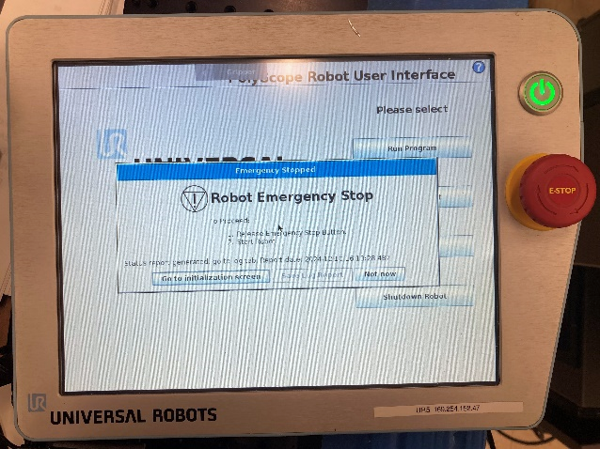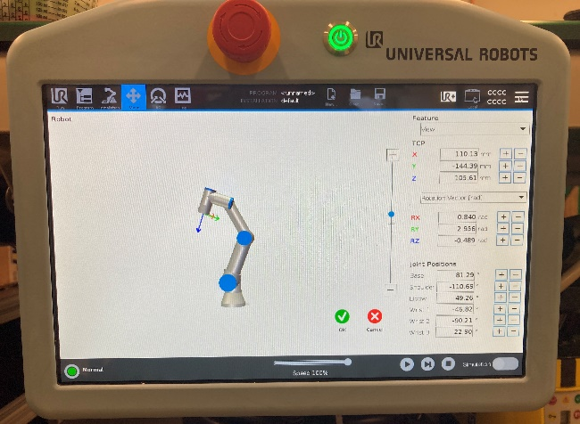
Figure 1: The front of the teach pendant for the CB (left) and E-Series (right) controllers. The emergency stop is the large mushroom button on the left and top of the CB and E-Series pendants, respectively.

Mechanical Hard Stops

Only joint 6 on the UR3 has infinite rotational capabilities. All other joints on the UR3, and every joint of the UR5 and UR10 are limited in rotational range by mechanical hard stops to prevent damage to the robot’s drives. These hard stops physically prevent the robot from moving beyond a set point.

Soft Axis Limit Switches

The Universal Robots robot system imposes adjustable software-defined limits on the ranges of the axes, and automatically stops the robot if any of these ranges are exceeded. These limit switches are always enabled, but are principally used for machine protection (they are adjusted such that the robot cannot hit the mechanical end stops) and can be edited by the operator to modify the active work volume of the robot.

The UR CB3 and E-Series controllers have the option of setting Cartesian axis limits to prevent the robot from moving beyond certain points in the environment as an added protective measure. These Cartesian limits apply only to the robot’s end effector, however, and it is possible to drive other parts of the robot beyond these limits.

The UR CB2 controller does not have Cartesian axis limiting.

Collision Detection

The Universal Robots controller monitors joint currents and torques at all times, halting the robot on over-current or over-torque events. Collision detection is always running while the robot is powered on, and will halt the robot if it measures that it has encountered forces in excess of 150 N, causing the robot to issue a safeguard stop.

This value may be adjusted on the controller to be more or less sensitive (i.e., triggering at lower forces). Collision detection may be inadvertently tripped if the robot is carrying an object that is heavier than expected. The object’s mass must be indicated in the tool description to prevent unintended behaviors.

Collision detection has been known to not be 100% reliable.

It has been observed that while the robot is accelerating quickly to high velocities, the currents necessary to accelerate the robot may be comparatively large. Impacts that occur while the robot is accelerating are not always detected, and may result in contact forces in excess of 600 N. While this prominently impacts older models of robots, as a best practice is it advised to use reduced speeds and lower accelerations.

Current monitoring may also be negatively impacted by power fluctuations. It is recommended the UR robots not be powered by a battery-fed DC-AC inverter, as low battery charge may result in inconsistent or unpredictable power to the robot controller.

Safety Input/Output Signals

Universal Robots provides the following safety interfaces on their controllers:
- Safeguard channels A and B – control signal to the UR controllers in automatic mode.
  - Decelerates the robot and limits arm power
  - Pauses robot program being executed
  - Must be reset manually (this requires operator to acknowledge the error, re-enable the arm, and restart the program)
- External E-Stop channels A and B – control signals to the UR controllers for external emergency stop devices
  - Emergency stops robot:
    - Issues stop category 0
    - Generates an error that must be acknowledged
  - Must be reset manually (this requires operator to acknowledge the error, re-enable the arm, and restart the program)

These connectors are located inside the controller, and are located on the far left of the array of terminal connectors (see Fig. 3).

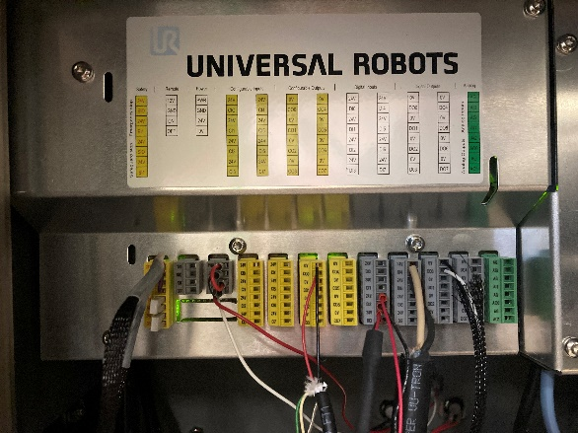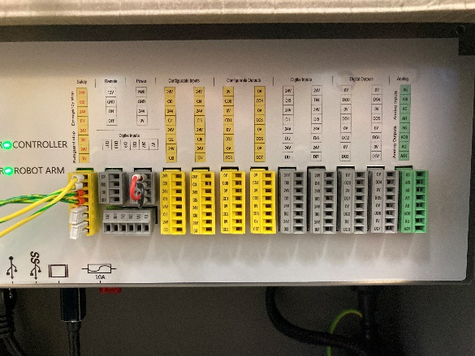
Figure 3: The safety signal connections of the teach pendant for the CB (left) and E-Series (right) controllers.

Each safety signal consists of two channels, A and B, which includes a source and a sync. Each channel’s sync must be connected to its respective source (e.g., the source for safeguard channel A is connected to the sync for safeguard channel A), and both channels must be fully connected for operation to be possible

Electronic Safety Circuit

The UR controllers maintain dual-channel safety system that constantly monitors all connected safety-relevant components and devices. In the event of a fault or interruption in the safety circuit, power to the robot’s drives is removed and the program is paused. A notification window will be displayed in the event of a safeguard event. When the safeguard event is cleared, the current program and the robot’s motions will automatically resume.

Safety Rated Stopping Functions

Table 3. Stopping functionality of the UR robots based on the operational mode and halting trigger.
Trigger | Result
Safeguard | STOP2
E-Stop pressed | STOP0
Encoder error | STOP0
Controller turned off / power failure | STOP0

The different stopping reactions of the robot system are triggered in response to different monitored events or as a reaction to operator action. The UR controllers may issue a stop category 0 (STOP0, robot is stopped immediately when the brakes are applied, the current program is stopped, and power to the drive is removed) or category 2 (STOP2, robot is stopped with a normal braking ramp, the brakes are not applied, and the drive are not deactivated) according to DIN EN 60204-1:2006 based on safeguard triggers. The stopping characteristics according to the operational mode and trigger are summarized in Table 3.

External Safeguards

Using the safety channels discussed previously, additional external safeties may be integrated into the robot’s controllers, either directly, through a safety PLC, or a custom safety circuit. These are not provided by UR, and must be integrated by NIST personnel.

The types, number, location, and integration method may change according to the needs of the robot application.

This section discusses safeguards, sensors, and signals that are recommended for the integrated robot system for the robot application. These are not the only safeguards that can be used, but reflect only those safeguards that have been used by the authors of this SOP.

Emergency Stops

Of all possible safeguards that can be integrated, the only ones that MUST be added are external emergency stops.

At least one external E-Stop button stop shall be integrated into the testbed. Any number of E-Stop buttons can be daisy chained serially to ensure that any actuation of an E-Stop button results in the entire circuit signalling a category 0 stop.

E-Stop buttons shall be positioned such that at least two people can actuate a stop action independently of each other outside of the robot’s work volume. Only safety-rated E-Stop switches (e.g., see Fig. 4) are permitted for use as E-Stop buttons.

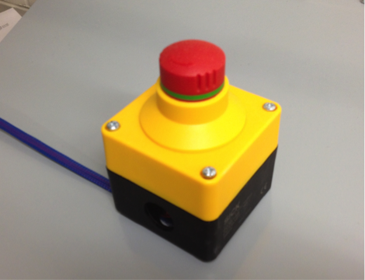
Figure 4: E-Stop buttons (yellow boxes) can be integrated into the robot testbed through the safety controller.

Light Tower

A single light tower indicates the functional state for a single robot in the robot testbed. Applications leveraging multiple robots should have separate light towers for each robot to indicate their individual states. Light towers shall be rigidly installed such that they are visible from all angles of approach, and may be integrated either vertically or horizontally. Separate indicator lights may also be used provided they are linearly arranged such that their functionality and relation to each other remains clear (e.g., see Fig. 5).

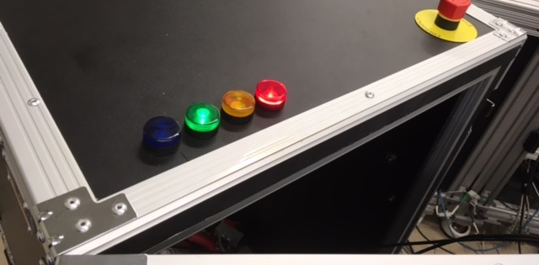
Figure 5: The light tower for one testbed has been integrated into a separate cabinet designed for transportation and storage of the robot.

Audible warnings are not required for use to alert the operator of changes in robot state.

Table 3 indicates the messaging and order conventions adopted by ISD’s PHRI laboratory. In summary, the critical elements to be conveyed include: the state of the robot’s drives, possible error state(s) of the robot, and whether or not safeguards are functioning correctly. Some tasks may involve the use of muting safeguards, in which case such states shall also be indicated.

Table 3. ISD Universal Robots testbed light tower function.
Light Color | Function
RED | When lit, the RED light indicates that the robot’s drives have been energized. The robot may move without warning, so all personnel should treat the robot as though it was active.
AMBER | When lit, the AMBER light indicates a safety signal has been triggered and the robot is in a safeguard fault state. If the RED light is also illuminated, the robot may start moving as soon as the safeguard signal is cleared.
GREEN | When lit, the GREEN light indicates that powered safeguards (e.g., laser scanners or light curtains) and safety systems are active and are functioning as expected. The functionality of unpowered safeguards (e.g., safety mats, enabling devices, etc.) are not indicated by the GREEN light unless integrated into a powered safety system.
BLUE | When lit, the BLUE light indicates one or more safeguards have been muted, allowing the robot to move even under conditions that would normally cause it to stop/pause. If the BLUE light is lit, all personnel should assume that the safeguards are being ignored.

Laser Area Scanners

Laser-based, safety-rated area scanners detects objects around the robot testbed in both protected and warning zones. Protected zones cover the area immediately surrounding the robot’s working volume. When a scanner detects an undefined object, the scanner activates the safeguard signal, stopping the robot if it is in automatic mode unless its signal is muted.

Warning zones cover the areas leading up to the protected zone and 3000 mm from the center of the sensor. Beyond 3000 mm, the area scanner’s ability to detect smaller objects (e.g., the cross-section of a leg) is diminished due to the spread of adjacent detection beams. When the scanner detects an object within the warning zone, a signal is sent through a connected safety system, but does not require the robot to stop.

Pressure-sensitive Mats

A safety-rated, pressure-sensitive mat may be placed on the ground just outside of the robot’s work volume. This mat would tie into the safeguard circuit, and triggers a sensor-based safeguard stop when someone or something applies pressure.

Enabling Devices

Three-position enabling devices may be integrated into the system as operational mode switches into the C12 and C13 inputs on the safety signal connection (each with a respective, separate 24V output located above the input). By default, both the CB and E-Series controllers support only a single external enabling device to be added. Additional enabling devices can be added by means of a custom safety circuit.

Powering and Initializing the Robot

One or more personnel are required to be on station when operating the robot. While the drives are enabled, at least one person must be manning an E-Stop button. Whenever an operator is working inside the safeguarded space, that operator must have an enabling device, a teach pendant, or an E-Stop device.

Prior to turning on power, visually verify the following:

- Mechanical mounting of robot to platform, verifying that the robot is firmly attached and stable.
- All electrical connections are secure.
- All applicable utility connections (e.g., air, communications, or auxiliary sensor and control cables) are secure.
- All peripheral equipment and systems are stable and out of the way.

The operator shall perform the following steps when turning the robot power on:

- Verify that the robot is ready, including verifying that cables and components are secure.
- Verify that no one is inside the robot workzone. If so, then the operator shall notify persons inside the workzone that the arm power is going on.

NOTE: While the robot is initialized, the drives are active and the robot is awaiting motion commands. Such commands may be sent remotely, so it should be assumed the robot might move without warning. When the robot is not in use, disable it by pressing the “OFF” button on the Initialization screen on the teach pendant, or by pressing one of the E-Stop buttons.
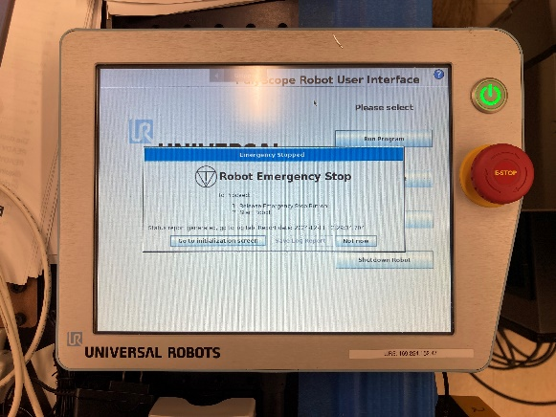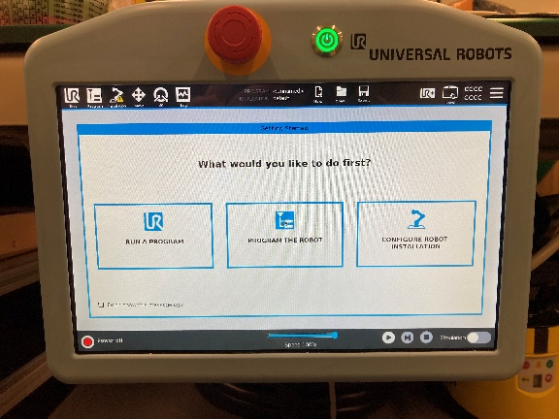
Figure 6: The front of the teach pendant. The robot is turned on by pressing the silver power button at the top-right corner of the CB teach pendant, or in the top center of the E-Series teach pendant.

Turning on the Robot

Process

- Press the power button on the teach pendant (see Fig. 6). This will turn on the controller, which supplies the robot with power.
- Allow the robot to boot normally.
- On the CB teach pendant: You will be presented with a prompt stating that the robot has changed modes (CB2) or is in an emergency stop state (CB3), and will then be instructed to go to the initialization screen. Using your finger, press the “Go to initialization screen” button.
- On the E-Series teach pendant: You will be shown the default “What would you like to do first?” screen. Using your finger, press the red button on the lower left corner of the screen. Once the startup is complete, the user will be prompted to initialize the drives.

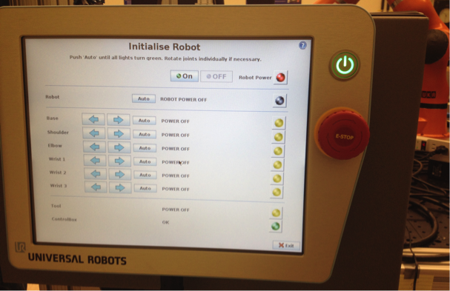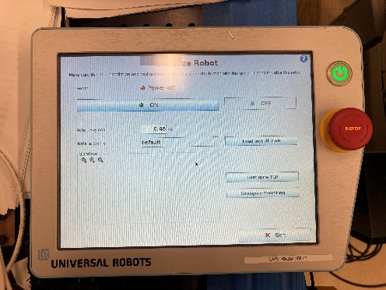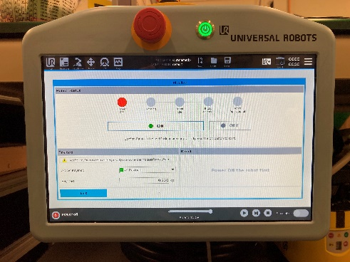
Figure 7: On the initialization screen the user will be presented with options to turn on and off the robot. Depending on the version of the controller, this screen will have a different appearance. The CB2 controller (top left) will show the states of all joints, while the CB3 (top right) and E-Series (bottom) controllers will not.

Hazard Assessment

Specific Hazard (Explanation) | Hazard Source | Severity | Occurrence Likelihood | Controls | Controlled Likelihood (Explanation) | Controlled RHI
Electrical fire could occur when turning on the robot due to electrical component failure or short | 120 VAC coming into the robot controller at about 5A | Severe injury (up to second degree burns) | Very unlikely (has not happened to our knowledge, and could occur only on initial power-up) | Engineering:  Robot controller is enclosed in a fire-resistent metal housing. Fire would be contained.  Power system is fused, and mains power is on a circuit breaker.  Administrative:  Safe practices, including the review and demonstrated understanding of the SOP. | Improbable (use of both fuses and circuit breakers to preempt circuit overloads; injury from fire is improbable, as any fires that occur would be contained) | 1
Electrical shock could occur when turning on the robot due to electrical component failure or short | 120 VAC coming into the robot controller at 5A, to which the teach pendant is connected.  24VDC leaving the robot controller to the robot at up to 5A. | Significant injury (low-voltage electric shock) | Slight (has not happened to our knowledge, and control box is grounded to earth and the robot and teach pendant are shielded) | Engineering: All ower is grounded to earth. Power system is fused, and mains power is on a circuit breaker.  Administrative: Safe practices, including the review and demonstrated understanding of the SOP. | Improbable (use of both fuses and circuit brekaers to preempt circuit overload; all electronic components are also grounded to earth) | 1

Initializing the Robot

CAUTION: RISK OF STRUCK-BY AND PINCHING/CRUSHING HAZARDS

Process

Initializing the robot does not require the operator to be inside the robot’s work volume. The CB2 controller requires large motions of the robot to initialize the encoders, while the CB3 and E-Series controllers require only minimal motions. All personnel shall be outside the robot’s work volume while initializing the robot.

- With your finger, press the “On” button at the top of the screen. This will boot the drive amplifiers and energize the robot’s joint motors, but will not release the brakes.
- Wait for the drives to boot.(the status next to each entry on the joint list will say “ready” once this is complete). Continuing beyond this point, the robot will move to measure and validate its joint motor encoders. The area around the robot shall be clear of obstacles and personnel.
- Press the “Start” button on the teach pendant screen. The brakes will release and the robot will begin to move.
  - On the CB2 teach pendant: Press and hold the “Auto” button while the joints calibrate. Each of the joints will begin moving from their current configuration.
    - If the robot looks like it will collide with its environment or itself, release the “Auto” button and then press and hold it again. This will reverse the direction of motion for any joints that have not yet been calibrated. Once an individual joint has been calibrated, it will automatically stop moving.
    - To manually initialize the joints, use the left and right arrow keys on the teach pendant to move each joint individually.
    - The status for each joint will change from “Initializing” to “OK” as they are calibrated, and the status indicator at the right of the screen will change from yellow to green.
  - On the CB3 and E-Series teach pendant: All of the robot’s joints will move slightly from their current configuration, but the range of motion will be small to prevent unnecessary risk.
- At this point the robot is powered, initialized, and is ready to move. While the robot will not move unless running a program or being manually jogged, all personnel around the robot shall be aware that it is now possible the robot can move at any time and in any direction without any advanced warning. Close the intialization screen to return to the main menu.

Hazard Assessment

Moving the Robot

CAUTION: RISK OF STRUCK-BY AND PINCHING/CRUSHING HAZARDS

Moving the robot may result in parts of the body or objects in the environment being struck, pinched, or crushed by the robot and/or its tooling. This applies to all modes of moving the robot, including jogging the robot using the move screen, Freedrive mode, or while the robot is running a program. Keep limbs away from pinch points (e.g., between adjacent links at the robot’s joints, or between any part of the robot and rigidly-mounted parts of the environment) while moving the robot. Keep head and face away from the robot. Apply an E-Stop when not actively using the robot.

Once initialized, the robot can be moved under its own power. The UR robots do not have separate “teach” and “automatic” modes, and an enabling switch is not required to jog the robot.

Commanding Motions Using the Move Screen

Process
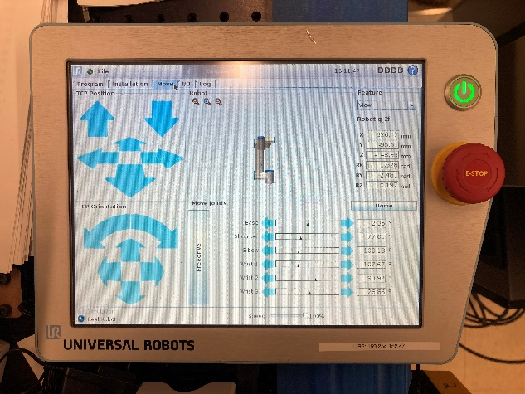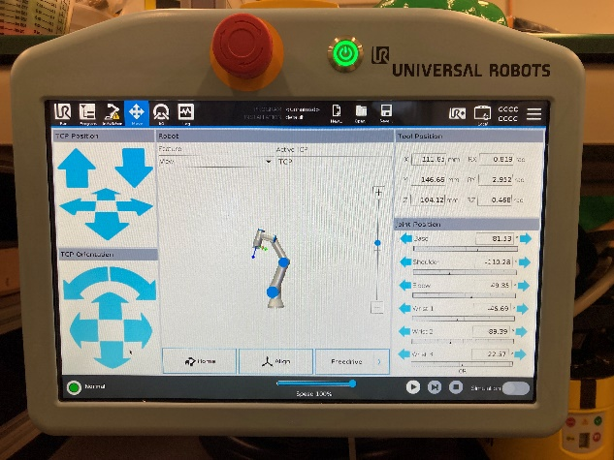
Figure 8: The Move screen has similar buton layouts for the CB (left) and E-Series teach pendants.

- From the main menu, navigate to the “Move” screen (Fig. 8)
  - On the CB teach pendant: press the “Program robot” button, and select the “Move” tab at the top of the screen
  - On the E-Series teach pendant: select the “Move” tab at the top of the screen
- At the bottom of the screen, the “Speed” adjuster modulates the maximum possible speed of the robot’s joints. By default, this is set to 100% (1000 mm/s)
- On the left of the screen are Cartesian motion controls, where the coordinated motions of the joints are commanded in the Cartesian coordinate space relative to the base frame of the robot
  - The top-left window commands linear motions along the X, Y, and Z axes using the blue arrows
  - The bottom-left window commands rotations of the tool around the defined tool center point on the X, Y, and Z axes using the blue arrows
  - The current joint values and Cartesian position of the tool will be updated as the robot moves
- Motions of the robot can also be commanded on a joint-by-joint basis by adjusting the joint sliders (or entering specfic angle values) in the Joint Position window (bottom of the screen on the CB teach pendant, or on the bottom-right of the screen on the E-Series teach pendant).
  - Pressing and holding the arrows will make the respective joints actuate, causing the robot to move
  - The current joint values and Cartesian position of the tool will be updated as the robot moves
  - The positive and negative extremes of the slider represent the maximum allowable motion limits for each joint. Attempting to move the robot beyond these limits will cause an error message regarding joint limits being met.
- Pressing the field inputs for the tool position (white boxes with numbers) will cause a motion command window to appear in which specific joint values or Cartesian coordinates can be manually set
  - Specific values can be entered into each field directly using the on-screen keyboard
  - The orientation can be changed between an axis-angle (“rotation vector,” default) or Euler angle representation, in either radians (default) or degrees
  - Changes to these fields will not take effect until the “Okay” button is pressed
  - You will be asked whether you wish for the robot to move itself (“Auto”) or await user commands to move the robot to its commanded position (“Manual”)

Hazard Assessment

Jogging Using the Freedrive Button

CAUTION: HEAT RISK

Freedriving the robot involves physically touching the robot. Robot joints and links may be hot due to extended use.

An alternative to using the Move screen is to leverage the robot’s gravity compensation (“Freedrive”) mode in which the tool and joints can be moved by the user physically pushing or pulling on the robot.

Process

Freedrive does not require the user to be on a specific window or menu. To enable Freedrive, do the following:

- With one hand, grasp the robot tool firmly, but do not push or pull on it. At this stage, you are merely supporting the weight of the robot in the event the tool mass and/or robot installation is not properly configured.
  - The tool will move downward if a tool mass larger than what it is expecting is present, or move upward if the tool mass is lower than what is expected
  - The tool may move rapidly in a random direction if the robot’s installation is not set properly. Review the UR manual for instructions of how to configure the installation.
- With the other hand, press the black Freedrive button located at the top-center of the back of the teach pendant. This will release the brakes and the robot’s joints will move based on the user’s actions while holding onto the tool.
- Gently push/pull/rotate the tooling to the desired pose, or adjust the joints individually to the desired configuration.
  - Pushing/pulling too hard, or attempting to move the joints too quickly may result in a safeguard fault. The resulting error screen must be cleared before Freedrive can be re-engaged.
  - The robot is monitoring and interpreting joint currents to effect pose changes based on its gravitational model, and is velocity-limited based on the set maximum speed. Larger payloads and/or lower maximum speeds may result in reduced responsiveness to user inputs.
- Release the Freedrive button once the robot is in the desired position/configuration to disable Freedrive mode

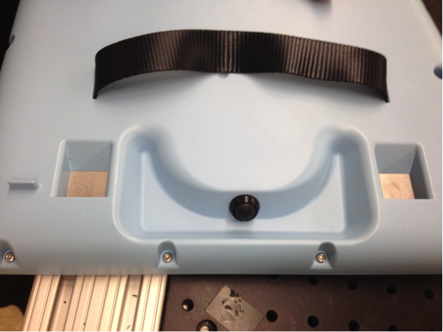
Figure 9: The Freedrive button located at the top-center on the back of the CB teach pendant.

Hazard Assessment

Safety Verification Procedures

The required safety features shall be verified at the beginning of each month. The date and the signature of the authorized operator of the robot system performing the verification shall be entered in a log kept with the robot testbed.

Verify Robot Activation

- Turn on the robot per Section 4.1
- Visually verify that the power button on the teach pendant is illuminated and the screen is active
- Initialize the robot per Section 4.2
- Visually verify the robot is powered on and the drives are active
- Turn off the robot (not the controller) by pressing the “OFF” button on the initialization screen of the CB teach pendant, or the power screen of the E-Series teach pendant.
- Visually verify the robot’s power is OFF (drives are disabled and the joint motors are deenergized) and the brakes are engaged

Verify Local E-Stop

With the robot powered on:

- Initialize the robot per Section 4.2
- Visually verify the robot is powered on and the drives are activated
- Press the emergency stop button on the teach pendant
- Visually verify the teach pendant status
  - Message window displays the message, “EMERGENCY STOPPED”
- Press the “Okay” (CB2) or “Go to initialization screen” (CB3 and E-Series) button to return to the initialization screen
- Visually verify the teach pendant status
  - The robot status will indicate that it is “EMERGENCY STOPPED”
  - On the CB teach pendant: The “ON” button is disabled. The CB2 teach pendant will also give an individual joint status of “EMERGENCY STOPPED”
  - On the E-Series teach pendant: The “Start” button is disabled
- Twist the E-Stop button on the teach pendant to release
- Visually verify the teach pendant status
  - On the CB teach pendant:
    - Robot “ON” button is enabled
    - Robot status is listed as “INITIALIZING”
    - On the CB2 teach pendant, all joint status states listed as “READY”
  - On the E-Series teach pendant: Robot “Start” button is enabled
- Initialize the robot per Section 4.2

Verify External E-Stop Buttons

With the robot powered on:

- Initialize the robot per Section 4.2
- Visually verify the robot is powered on and the drives are activated
- Press the external E-Stop button
- Visually verify the teach pendant status
  - Message window displays the message, “EMERGENCY STOPPED”
- Press the “Okay” (CB2) or “Go to initialization screen” (CB3 and E-Series) button to return to the initialization screen
- Visually verify the teach pendant status
  - The robot status will indicate that it is “EMERGENCY STOPPED”
  - On the CB teach pendant: The “ON” button is disabled. The CB2 teach pendant will also give an individual joint status of “EMERGENCY STOPPED”
  - On the E-Series teach pendant: The “Start” button is disabled
- Twist the external E-Stop button to release
- Visually verify the teach pendant status
  - On the CB teach pendant:
    - Robot “ON” button is enabled
    - Robot status is listed as “INITIALIZING”
    - On the CB2 teach pendant, all joint status states listed as “READY”
  - On the E-Series teach pendant: Robot “Start” button is enabled
- Initialize the robot per Section 4.2

Verify Teach Pendant Functionality

With the robot powered on:

- Initialize the robot per Section 4.2
- Visually verify the robot is powered on and the drives are activated
- Verify correctness of axes
  - Navigate to the move screen
  - Press and hold either the left or right arrow for each of the six joints separately; verify robot motion is correct and the values displayed are increasing/decreasing accordingly
  - Press and hold the robot move up or down arrow, verify direction of motion is correct
  - Press and hold the robot forward or backward arrow, verify direction of motion is correct
- Verify Freedrive functionality
  - Press and hold the Freedrive button on the back of the teach pendant
  - Verify robot is not moving (if the robot moves up or down, the mass setting for the tool is too high or too low; if the robot moves in a different direction, the configuration settings for the installation of the robot are incorrect or one or more joints are experiencing errors in current monitoring)
  - Release the Freedrive button
  - Press and hold the Freedrive button
  - Gently grab and hold the tool or the tool flange
  - Attempt to push the robot upward, downward, and to the sides
  - Verify the robot’s direction of travel matches the direction you were pushing/pulling
  - Release the tool or tool flange
  - Gently push on any link or joint directly
  - Verify the robot’s direction of travel matches the direction you were pushing
  - Release the Freedrive button

Working Inside the Robot’s Work Volume

CAUTION: RISK OF STRUCK-BY AND PINCHING/CRUSHING HAZARDS

Personnel who must work within the robot’s work volume to perform, for example, set-up, installation, or troubleshooting tasks, shall be familiar with the basic workplace safety and robot safety. Personnel unfamiliar with workplace safety precautions (such as the use of safety glasses, and recognizing and eliminating trip hazards) should take the appropriate safety classes.

The following are the robot-specific safety precautions personnel should follow when working within the robot’s workzone:

- Be familiar with the location of the robot E-Stop buttons for the robot testbed. The E-Stop buttons remove power from the robot drives and apply the brakes.
- Before reaching inside the robot’s workzone, check to see if the robot controller is on and whether someone else is working with the robot. If someone is working with the robot, notify that person that you plan to work inside the robot workzone. Notify the person again if you plan to re-enter the robot workzone after a prolonged absence.
- When not actively working with the robot, it is strongly recommended to leave the robot’s work volume, disable the robot, and/or activate an E-Stop button.

Programming Using the Teach Pendant

When possible, the operator should remain outside the robot’s work volume when teach programming with the pendant.

CAUTION: RISK OF STRUCK-BY AND PINCHING/CRUSHING HAZARDS

CAUTION: ERGONOMIC AND TRIPPING/FALL RISK

Programming using the teach pendant is typically done while holding the teach pendant. The weight of the teach pendant may cause ergonomic strain, and the cable connecting the teach pendant to the controller presents a tripping hazard.

Programming Outside the Robot Work Volume

The operator shall follow these steps when using the teach pendant outside the robot’s work volume. In situations where additional people are within the robot’s work volume during teach programming, it is the responsibility of the operator holding the teach pendant to notify personnel within the robot’s work volume that the robot is (or will be) on and to ensure that the robot does not hit or injure others.

- Inform any personnel within the robot’s work volume that activities with the robot(s) are about to begin
- Initialize the robot(s) per Section 4.2
- Verify teach pendant functionality is working (see Section 5.4)
- Proceed with programming. Be prepared to press the E-Stop button on the teach pendant if an imminent collision is observed or the robot’s behavior is not consistent with expected performance.

Programming Inside the Robot Work Volume

Sometimes it is necessary for the operator to enter the workzone for improved visibility and accessibility to the application. The operator shall follow these steps when using the teach pendant inside the work volume. In situations where additional people are inside the work volume during teach programming, it is the responsibility of the operator holding the teach pendant to notify personnel inside the work volume that the robot is on and to ensure that the robot does not hit or injure others.

- Inform any personnel within the robot’s work volume that activities with the robot(s) are about to begin
- Initialize the robot(s) per Section 4.2.
- Verify teach pendant functionality is working (see Section 5.4)
- Inform personnel present you are about to enter the robot’s work volume prior to entering.
- Proceed with teach programming.
- When done with tasks requiring presence inside the robot’s work volume, immediately exit the robot’s work volume.

Maintenance

Only authorized users shall conduct maintenance on the robot.

WARNING: RISK OF ELECTRICAL SHOCK
WARNING: RISK OF HEAT/FIRE

Do not service the robot or its controler while powered.

Prior to any service or maintenance activity, the robot shall be actuated to a neutral position such that any potential energy in the system is minimized. The robot and its controller shall be de-energized prior to attempting to access the electrical and mechanical components.

Physically unplug the robot, the controller, and the safety system (if provided) to ensure that the robot is not re-energized inadvertently. After unplugging the equipment, allow the robot and controllers to sit for at least 30 minutes to allow for any residual charge in the systems’ capacitors to dissipate, and the equipment to cool to room temperature.

Refer to the appropriate robot service manuals for instructions for replacing/repairing components on the robot and controller.

Emergency Response Plan

Event: Equipment Fire

In the event of fire, immediately contact NIST Safety at x2222 to report the fire.

Authorized personnel may use an approved ABC fire extinguisher (combustible materials, flammable liquids, and flammable gases) to attempt to extinguish the fire. Acceptable fire extinguisher types include dry powder, alcohol-resistant foams, and carbon dioxide. An appropriate fire extinguisher must always be present in the same room as the robot, and all related personnel shall be informed of its location and trained in its use.

Do not use water to combat fires. Water may spread the flames and/or be insufficient for reducing temperatures of flammable materials below the flash point.

Do not resume use of the robot again until it has been inspected for damage that could negatively impact its safety.

Event: Forceful Impact with Human

Should accidental striking (i.e., non-constrained impact) occur with the robot, a held part (including one that may have been ejected from the robot’s gripper or pushed into contact with the operator), immediately move away from the robot and depress the E-Stop button.

Check all personnel for potential injuries such as cuts or bruising, contacting NIST Safety at x2222 if there has been an injury.

Reassess the activity’s hazard review—including the design of the working environment, the role of the operator in the activity, and selection of parts/tooling—to determine what controls can be added to prevent such events from occurring again.

Do not resume operations until the hazard has been mitigated.

Event: Crushing/Pinching

Keep hands and limbs away from crush/pinch points within the robot’s work volume while the robot is energized. Should accidental crushing/pinching occur:
- Immediately free the pinched/crush body part(s) away from the robot and move the impacted body part away from the robot when it is safe to do so.
- If the body part is pinned and extraction is not possible, attempt to jog the robot away from the body using Freedrive mode.
- If Freedrive mode cannot be enabled, individual joints may have their brakes released manually. To manually release a joint’s brakes, remove the blue plastic cover from the joint by removing the M3 screws. Press the plunger switch (see Fig. 10) to release the brakes.
- If the robot joints cannot be safely enabled to remove the risk state, or the brakes manually released, remove power from the robot by turning off the controller and unplugging it from the wall. With the power removed, the motors can be then safely back-driven. Alternatively, remove the four bolts connecting the robot to the mounting surface and move the robot away from the collision.

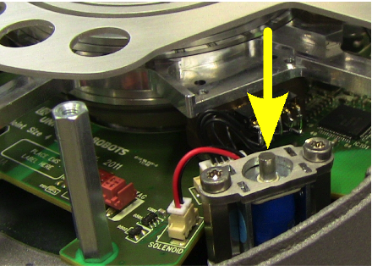
Figure 10: Brake release for an individual axis on the CB2 UR10.

Check all personnel for potential injuries such as cuts, bruising, or broken bones, contacting NIST Safety at x2222 if there has been an injury.

Power shall not be restored to the robot or its controller until physical access to all pinching/crushing hazards have been addressed with approved engineering controls.

Event: Contact with Forbidden Zones

Access of forbidden zones of the human body (e.g., head, face, or throat) to the mechanical and electrical parts inside the robot controller shall be prevented by safeguards at all times.

Should accidental contact occur, immediately move away from the robot, remove power from the robotic system, and disconnect the robot’s controller from the power source.

Check all personnel for potential injuries such as cuts or bruising, contacting NIST Safety at x2222 if there has been an injury.

Power shall not be restored to the robot or its controller until physical access to all moving components has been addressed with approved engineering controls.

Event: Robot Brake Failure

If the robot’s brakes fail while the robot is in operation, immediately remove power from the robot, and lock-out-tag-out the controller. The robot and its controller shall not be energized again until the robot has been serviced by an authorized service provider.

Event: Unexpected Robot Motion

Power fluctuations, unexpected/uncontrolled access to the robot’s network, controller errors, or unverified programs/inputs may result in the robot’s motions becoming erratic. If at any point the robot’s motions do not reflect what is expected:
- Immediately press the E-Stop button to halt all motions.
- Clear the error, and jog the robot to a known good configuration.
- If, while attempting to jog the robot, the unexpected robot motion manifests again, immediately press the E-Stop button and attempt to diagnose the issue with the robot controller. Having the robot be serviced by an authorized service provider may be required.
- Otherwise attempt to recreate the conditions under which the initial unexpected motions occurred, including any programs that might be running, external signals, or incurred forces/torques.
- If the unexpected robot motion manifests again, immediately press the E-Stop button and attempt to diagnose the root cause of the issue.
  - If the robot itself (including motors, current monitors, and wiring) or its controller is the cause of the issue, disconnect power and have the robot serviced by an authorize service provider.
  - If the robot program is the cause of the issue, attempt to debug the code in a controlled and safe manner.
  - If the power supply is the cause of the issue (including external power inverters, wall power sockets, cables, power strips, and connectors) replace the effected components with known good alternatives and attempt to diagnose the source of the electrical fault.
- Otherwise resume normal operations, being certain to specifically watch for the unexpected motions to manifest again.

Event: Unplanned Release of Energy

The unexpected release of energy may present different hazards depending on the conditions in which the energy was released and the nature of the energy released.

Electrical

Immediately disconnect all power (including batteries) from the robot and any ancillary equipment. Check all personnel for potential impacts from ejected materials, or burns from live circuits or hot surfaces, contacting NIST Safety at x2222 if there has been an injury.

Do not attempt to restore power to the system until all power lines and grounds have been inspected and known to be intact and in proper working condition. Replace any damaged components or contacts showing wear or burning.

Pneumatic

An audible hissing will be heard if an air line or chamber ruptures, warning the operator and any nearby personnel that the structural integrity of the robot has failed. Immediately turn off and disconnect the air source, and remove power from the system. Check all personnel for potential impacts from ejected materials, contacting NIST Safety at x2222 if there has been an injury.

Do not attempt to restore power to the system until the ruptures have been permanently fixed, or the soft pneumatic lines have been replaced with new components.

Maintaining low air pressure in the system will dramatically reduce the risk of injury from ejected materials.

Event: Contact with Hot Parts of the Robot/Controller

Access to the mechanical and electrical parts inside the robot controller shall be prevented by safeguards. Should accidental contact occur, immediately remove power from the robotic system and disconnect the robot’s controller from the power source.

Check all personnel for potential injuries such as cuts or burns, contacting NIST Safety at x2222 if there has been an injury.

Power shall not be restored to the robot or its controller until physical access to all moving components has been addressed with approved engineering controls.

Building Related Hazards

Event: Fire

If a fire event occurs in the building and the building fire alarm sounds, immediately turn off any powered equipment, place any tools/parts on the floor in a safe and stable position, and then evacuate the building per NIST guidelines for building evacuation.

Event: Hazardous Weather

If a hazardous weather event occurs and the building alarm sounds, immediately turn off any powered equipment, place any tools/parts on the floor in a safe and stable position, and then move all personnel to the shelter-in-place zone in the building in a safe and orderly fashion.

Event: Power Outage

Activate the E-stop button for any robotic equipment that was previously powered, and turn off the power to any equipment operating under backup or battery power.

Move to a safe location away from any hazards until power has been restored.

